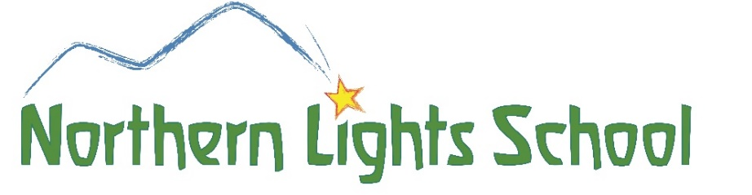

Job Opportunity!

Northern Lights School is an early childhood daycare center located in Saranac Lake, NY. Our mission is to nurture young children and their families through play and nature-based childcare and educational programming.

NLS has a summer internship position in our Mixed Age Preschool. This position could turn into part-time and/or substitute work throughout the year. Our summer program runs from July 6 to August 23. Work hours are from 8:45 to 4:45 with a half hour break.

We wish for warm, joyful, calm and dependable people with a passion for very young children, being outdoors, and either a familiarity with our school's philosophy or an eagerness to learn.

High school diploma and 1 year of experience with 3 to 5 year olds and 15 hours of continuing education is required. Coursework or a commitment to acquiring a childhood development certificate in early childhood education is a plus.

Please email info@northernlightsschool.org or call Polly 518.891.3206 for more information.

