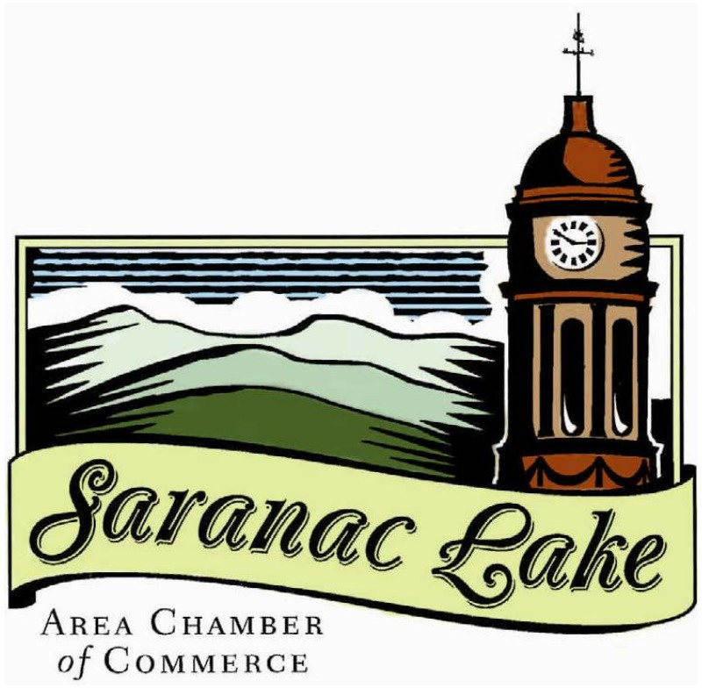

**BECOMING A MEMBER**

**CONTENTS**

ABOUT 3

WHO WE ARE 4

COMMUNITY BENEFITS 5

MEMBER BENEFITS

PERKS **6**

EXPOSURE **7**

AMPLIFIERS **8**

NEXT STEPS 9

**ABOUT US**

### MISSION:

**VISION:**

Act as a catalyst for business and community development in the greater Saranac Lake area.

Providing services and representation for its membership and generating economic development through promotional and marketing strategies.

### VALUES:

###### INTEGRITY

* We do everything with our values in mind.
* We assume the best of intentions in people, and give everyone the benefit of the doubt.
* We do what we say we are going to do.
* We do everything thoughtfully and with high quality.
* We give feedback directly, respectfully, and with a focus on solutions.
* We communicate our needs and expectations openly, and do not

get angry at others’ failures to fulfill expectations we never clearly set.

* We actively listen and are open to feedback and improvement.
* We take responsibilities for our mistakes and learn from them.
* We acknowledge our roles in conflicts and participate in finding and implementing solutions.

###### ACTION

* We plan to the best of our abilities and take timely actions using available information.
* We take calculated risks and view failures as learning opportunities.
* We are not afraid to change course as more information becomes available.

###### TRANSFORMATION

* We support each other and give everyone a chance to learn and to improve because we believe individuals are the key to societal transformation.
* We are not afraid to have courageous, sometimes even painful conversations that may lead to

the positive transformation of our organization, of Saranac Lake, and of the wider community.

* We recognize our role of supporting leaders and organizations to transform policies and systems.
* We encourage and create opportunities for diverse communities to support each other and build solidarity across identities.

###### EQUITY

* We are thoughtful about our privileges and how they affect our interactions with others.
* We create environments that allow for voices that are often less heard to be heard, including checking in with those who tend to be quieter, and asking more dominant voices to step back and do more listening.
* We acknowledge and celebrate the strengths and differences in others, and do not assume that the ways we are used to doing things are the only correct ways to do things.

###### COMMUNITY

* We create a space for everyone. We actively build an environment where everyone of any race, ethnicity, class, age, religion, sexual orientation, gender identity, accessibility needs, or country of origin feels welcomed and seen.
* We welcome and encourage energetic conversations across diverse perspectives and challenge each other respectfully.
* We take time to get to know each other as individuals.
* We support each other to learn and to grow.
* We have a good sense of humor and find fun and joy in our work.
* We are thoughtful of everyone’s needs when coordinating events and activities. We consider accessibility challenges and strive to accommodate everyone.
* We are thoughtful of our impact on the environment as we do our work.

# WHO WE ARE

### BOARD OF DIRECTORS

##### CHRISSIE WAIS

*PRESIDENT*

Above the Treeline

1st term, expiration 2027

##### JOSH KING

*VICE PRESIDENT*

Hotel Saranac

1st term, expiration 2027

##### COREY HURWITCH

*TREASURER*

Adirondack Regional Airport 1st term, expiration 2025

##### AMY WENSKE

*SECRETARY*

Citizens Advocates

1st term, expiration 2026

##### MIKE NAVARRA

*Wilkins Agency*

2nd term, expiration 2027

##### EMMETT SMITH

*Northern Power & Light*

2nd term, expiration 2027

##### MARTHA SPEAR

*NYS Dept. of Civil Service*

1st term, expiration 2027

##### CAMERON MOODY

*CAN AM Rugby*

1st term, expiration 2028

##### ISABEL WILLIAMS

*Adirondack Artist Retreat*

1st term, expiration 2028

##### KATIE STEPHENSON

*Community Bank N.A*

1st term, expiration 2026

##### CHRIS KNIGHT

*North Country Community College*

2nd term, expiration 2026

##### TIFFANY REA-FISHER

*Adirondack Diversity Initiative*

1st term, expiration 2026

##### WILLIAM CHAPIN

*Adirondack Health*

1st term, expiration 2028

##### CRISTINE FARAH

*EXECUTIVE DIRECTOR*

Christine has lived in Saranac Lake for 10

### STAFF

years and moved here to attend Paul Smith's College after growing up in Yonkers NY.

She graduated with a degree in Hotel resort and Tourism Management, after graduation spent some time working in Ireland and returned to Saranac Lake where she has been a Senior Sales Manager in the hospitality industry before taking on the role of Executive Director of the Chamber.

When she is not working you can find her traveling spending time with family and walking her dog on the trails of the ADK.

# BENEFITING

**OUR COMMUNITY**

#### EVENTS

**COMMUNITY CONVERSATIONS**

The Chamber brings the community together by hosting important conversations about issues and topics that affect us all. Is there something you would like the community to be more informed about? Connect with us and we will make it happen.

We bring the community together to create a buzz in town. The Chamber provides opportunities for bringing more business into the area through community events.

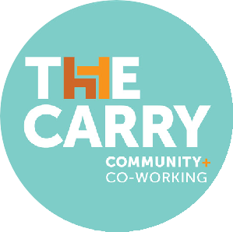

The Chamber is a co-founding partner with Point Positive and Adirondack Frontier for The Carry. The co- working space offers freelancers and entrepreneurs an area to get work done right in downtown Saranac

Lake. No matter where you are in your entrepreneurial journey it helps to be able to get out of the house and into an affordable working space. The Carry offers wifi, a copier/printer, and clean quiet work environment.

#### WELCOME CENTER

The Welcome Center is for Everyone! Whether you are new to the area, looking to be more involved in the community or just visiting, the Welcome Center has resources for all. We are here to help and point everyone in the right direction.

**Find us at 39 Main St, Saranac Lake!**

#### SCHOLARSHIPS

Each year the Chamber, with the help of St. Joseph’s Rehabilitation Center, provides a civically minded graduating senior with a $1000 dollar scholarship to the college of

their choice. If the recipient of the high school scholarship attends Paul Smith’s College or North Country Community College, the college will then match their $1000 award. Investing in young people is investing in the future of the Saranac Lake area.

# BENEFITING OUR MEMBERS

## PERKS*

**HEALTH INSURANCE ASSISTANCE**

As a member you have access to a health insurance broker and NYS marketplace navigator that can help walk you through the options available for your business and employees.

The Chamber also offers specific dental and vision plans for members and their employees.



#### ONLINE JOB BOARD

The Chamber helps promote your business’s open positions. Send us your job postings and we will post them on our online job board.



“I have to tell you that I have had

#### COMPLIMENTARY ASSISTANCE WITH DIGITAL MEDIA MARKETING

**Get help with:**

* Image and logo resizing
* Basic social media set up
* Utilizing hash-tags
* Growing your digital following

great success with posting them on your job board. I have two wonderful employees who mentioned your job board when I asked how they heard about the job. So thank you for doing this!!”

*– Gina Pollock, Director of Business Administration and Marketing, Saranac Village at Will Rogers*

**%**

#### MEMBER ONLY DISCOUNTS

Get exclusive access to discounts including:

* 25% off annual membership of The Carry
* Scheduled free use of the chamber copier/printer
* Discounted ad placement in the Visitor’s Guide
* 25% off enhanced listings on Saranaclake.com

Offer discount opportunities to other members to help us expand our offerings and drive more traffic back to your business

# BENEFITING OUR MEMBERS

## EXPOSURE*

#### WELCOME CENTER



Put promotional materials in the welcome center to gain more exposure and educate the public and travelers about your business. Keeping the welcome center up to date on your business is a great and easy way to gain exposure with the public at zero extra

cost. We always advocate for our members when directing people to what they are looking for.

#### BUSINESSES HELPING BUSINESSES

Businesses helping businesses, that’s our motto. The chamber makes sure that local businesses come first and to help facilitate that we started the “Support Local” campaign. Promote our local economy with us. Display our “Support Local” signage, utilize our GIFs, and spread the word that in Saranac Lake, we shop local first. Everyone benefits from supporting local businesses!



#### INCLUSION ON CHAMBER PROMOTIONAL MATERIALS

Get discounts on Saranac Lake visitors guide ads, as well as inclusion in online directories, restaurant lists, etc.

We are always coming up with new ways to promote our members, increase exposure and to better get consumers, travelers, and locals the info that they need.



We value all of our members. We make it our goal to give shout-outs and features to every single one of them. Our “Spotlight Series” highlights each individual member in one of our weekly newsletters as well as posts on Facebook and Instagram.

#### RIBBON CUTTINGS

Starting a new venture? New location for a current business, maybe? We can help you get the word out. A ribbon cutting with the Chamber means getting exposure through our channels, engaging with the press, and celebrating your business with the community!

# BENEFITING OUR MEMBERS

## AMPLIFIERS*

#### WE KEEP YOU INFORMED

Subscribe to the newsletter and follow us on Facebook to stay in the loop about what’s going on at the Chamber.

#### BUSINESS CONSULTATIONS

Whether you are just starting out or looking for some fresh advice, we have you covered. Sit down one-on-one with us to learn more about the next steps for your business.

#### EVENT SUPPORT

We can help support business members with facilitating the steps of planning and hosting an event. Get one-on-one consultations on logistics, marketing, fundraising and more. The Chamber has helped support events like Winter

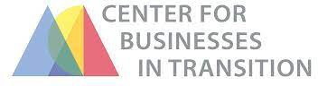

The Chamber partners with the Center for Businesses in Transition to help advise entrepreneurs in the community on the steps to take in selling or retiring from their business. Sit down with us one-on-

one to figure out strategies and next steps on your transition goals.

Carnival, First Night, Street Fest, Northern Current and 3rd Thursday Art Walks.



**NETWORKING**

Chamber organized networking opportunities get local business owners connected. Either host one in your own business or attend one at a fellow member’s. Everything from big to small, dressed up to dressed down, the Chamber has events ranging in all different styles to connect our members one-on-one.

#### BUSINESS BUILDER SERIES

The Chamber helps update businesses on current trends and policies to keep members informed for the future. We host webinars to help members learn the best business practices and collaborate with our members on topics and discussions to elevate our business community. Be on the lookout for our weekly newsletter to stay up to date on educational opportunities and helpful tips.

# NEXT STEPS

## MAKE THE MOST OF YOUR MEMBERSHIP

Sign up for a yearly membership

Subscribe to the newsletter and follow us on Facebook

Schedule a meeting with a staff person or board member to answer questions and get involved

Send us an update on your business and gain exposure through the chamber channels

Make sure you have fresh materials in the Welcome Center

Attend the next networking event or webinar

Collaborate with us on an upcoming project, event, or conversation

**Find out more information by contacting the chamber at 518.891.1990 or email** [**welcome@slareachamber.org**](mailto:welcome@slareachamber.org)